Summer Day Camp
Overview:

- Ages 4 – 12

- May 23rd – August 2nd, 2019

- Open 8:00am – 6:00pm

- Daily Chapel, Praise & Worship

- Rotational centers

- Breakfast, hot catered lunch & afternoon snack included in weekly tuition

Eastminster Presbyterian Church
Weekday Ministries Division
5801 Hugh Howell Road
Stone Mountain, Georgia 30087
770.469.9489
www.Eastminster.us

Eastminster School-Age Program

Caleb Clarke, Pastor

Celeste Sears,
Camp Director

5801 Hugh Howell Road
Stone Mountain, GA 30087
770.469.9489

www.Eastminster.us

Eastminster Presbyterian Church

Summer
Day Camp
2019

A Program of the Weekday Ministries Division
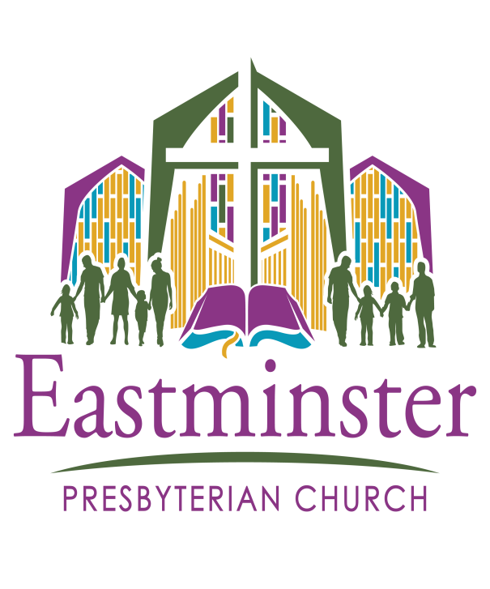

Summer Day Camp
Program Areas:

- Gym, with focus on a variety of sports, including soccer, basketball, volleyball, badminton, and more

- Arts and Crafts

- Music

- Daily Praise/Worship/Devotional

- Weekly Skits

- Summer Bridge Time

- Dance/Creative Movement

- Swimming

- Piccadilly Puppets

Weeks of Operation:

- May 23 & 24
- May 28 – 31 (closed 27th)
- June 03 - 07
- June 10 - 14
- June 17 - 21
- June 24 – 28
- July 01 – 03(closed 4^{th &} 5th)
- July 08 - 12
- July 15 - 19
- July 22 - 26
- July 29 – Aug 2

Eastminster Summer Day Camp

Our mission…
To provide a high-quality camp experience emphasizing the individual child’s developmental needs; to help the child in his or her mental, emotional, social, physical and spiritual development; and to offer peace of mind to parents with the knowledge that their children are well-supervised and loved.

Our staff…
is comprised of individuals from our community with a commitment to providing the best summer experience possible for the children of our program.

Our facility…
We are housed in the lower level of Eastminster Presbyterian Church, and in addition have access to the gymnasium, playground and Sanctuary.
Field Trips:

- Lunar Mini Golf

- Jim Nnark Party Animals Atl

- Atlanta Ice Forum

- Aurora Theatre

- Fun Xcess

- Adrenaline Climbing

- Gwinnett Stripers Party Deck

- Buccaneer Cove Water Park

- Escape The Room

- Malibu Grand Prix

Camp Cost:

- $200 per week for 1st child; additional children registering from the same family are $190 each per week. 3 Day Camp M-W-F is $160 per week for 1st child; additional children from the same family are $150each.

- $80 (non-refundable) registration fee covers the cost of all field trips a camp T-shirt; and 2 snacks daily

For More Information:

www.eastminster.us to register online or download registration forms

- Call 770-469-9489

